# **Chabot for AMS**

# **Project Architecture**

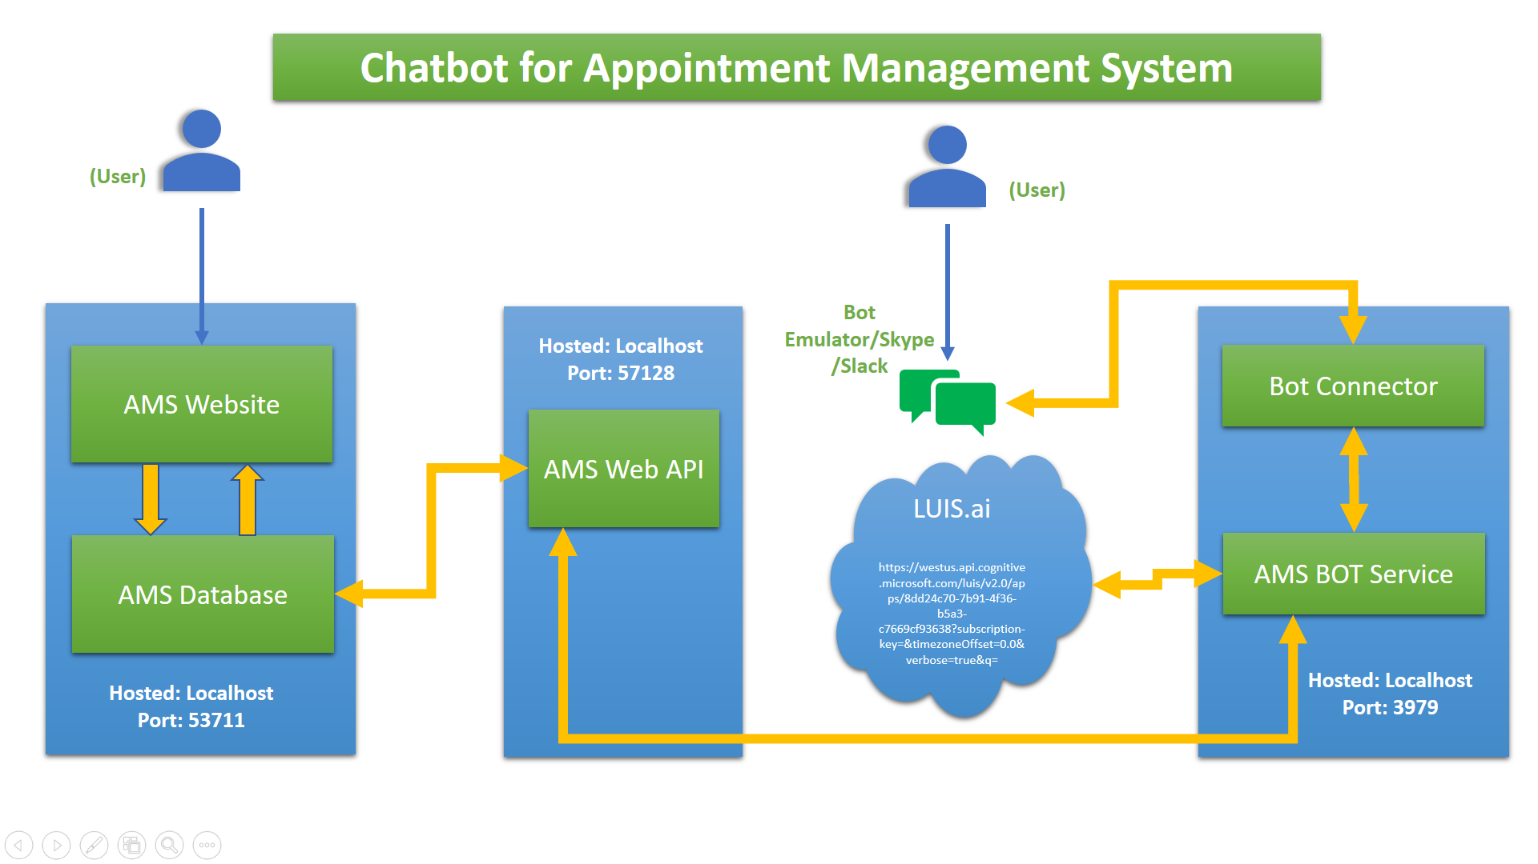

# **Project Components**

* AMS Website
* AMS Database (MS SQL SERVER database)
* AMS Web API
* Microsoft Cognitive Service (LUIS.ai Endpoint)
* Bot Connector & Bot Service

# **Project Component Description**

* **AMS Web API:** It is the WCF service which communicates with database and provides services to the user, format of the service result is in JSON format.
* **Microsoft Cognitive Service:** LUIS is the service from Microsoft, which takes input as text and predicts the user’s intents (his/her intentions) Entities (keywords useful in identifying intents) in a JSON format.
* **Bot Connector & Bot Service:** Bot Connector is the endpoint where user can communicate with BOT service using skype/emulator etc. Bot Service takes input from Bot connector, sends message to LUIS.ai endpoint, LUIS.ai predicts the intents & entities and sends the result to BOT service, based on the result BOT service communicates with Web API and gets the request done and sends result back to the Connector & user.

# **Project Implementation (LUIS.ai & Bot Connector)**

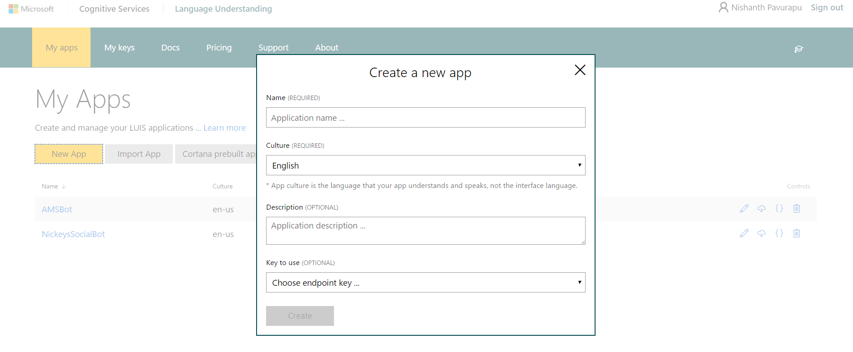

Creating new LUIS.ai endpoint

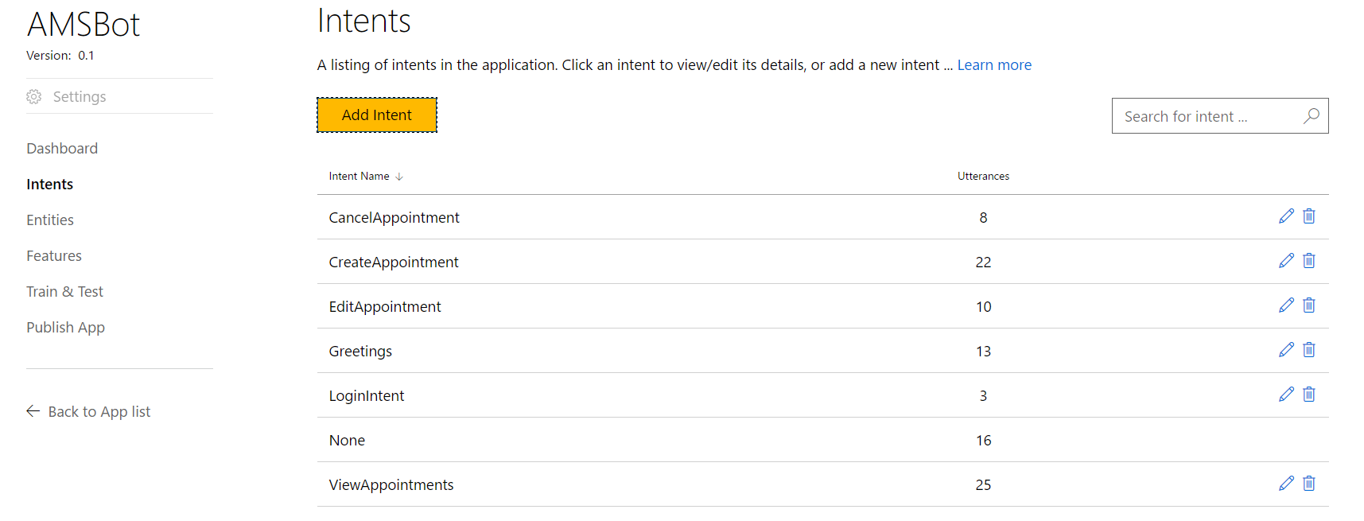

List of Intents

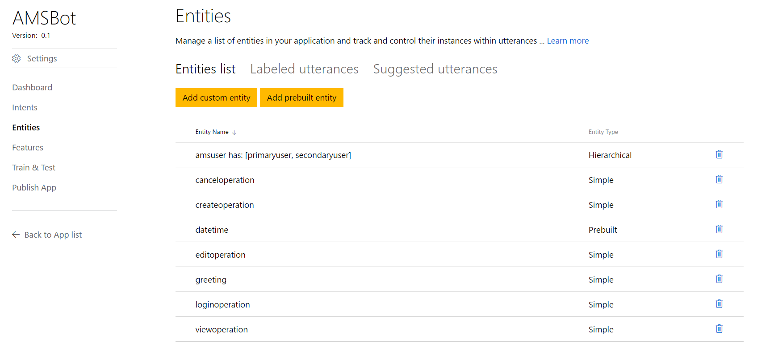

List of Entities

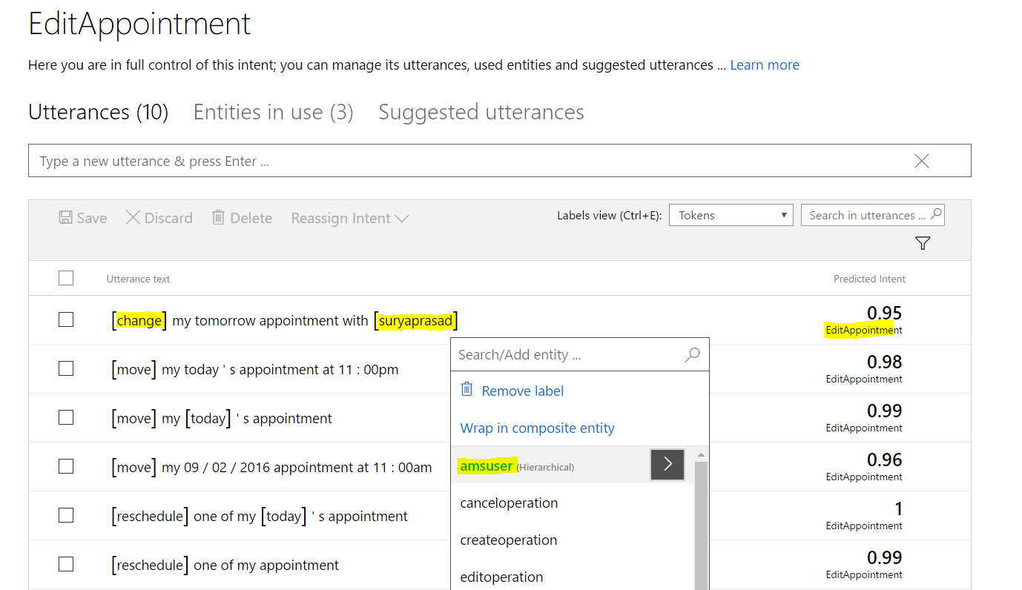

Adding sample utterances in Intents and identifying entities in the utterance and label them.

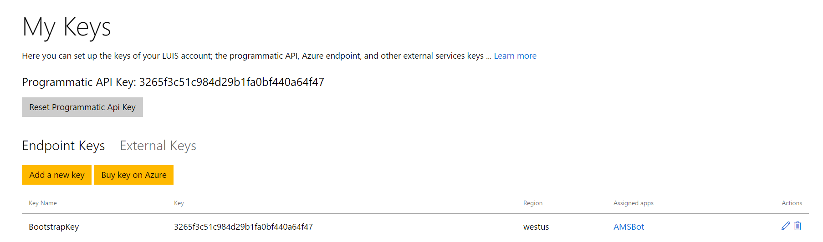

Creating an endpoint key, which can be accessed in the bot connector service.

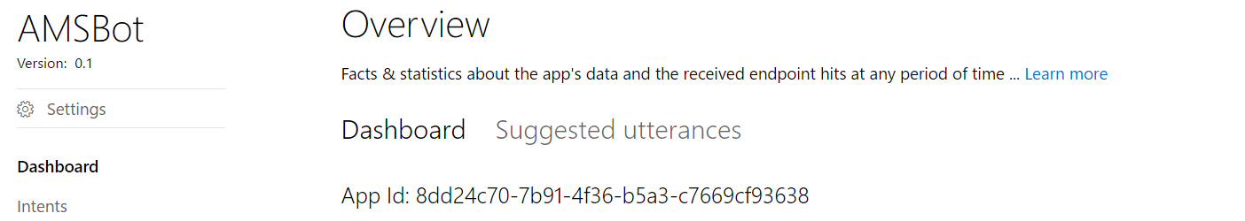

App ID, which will be used in the bot connector service.

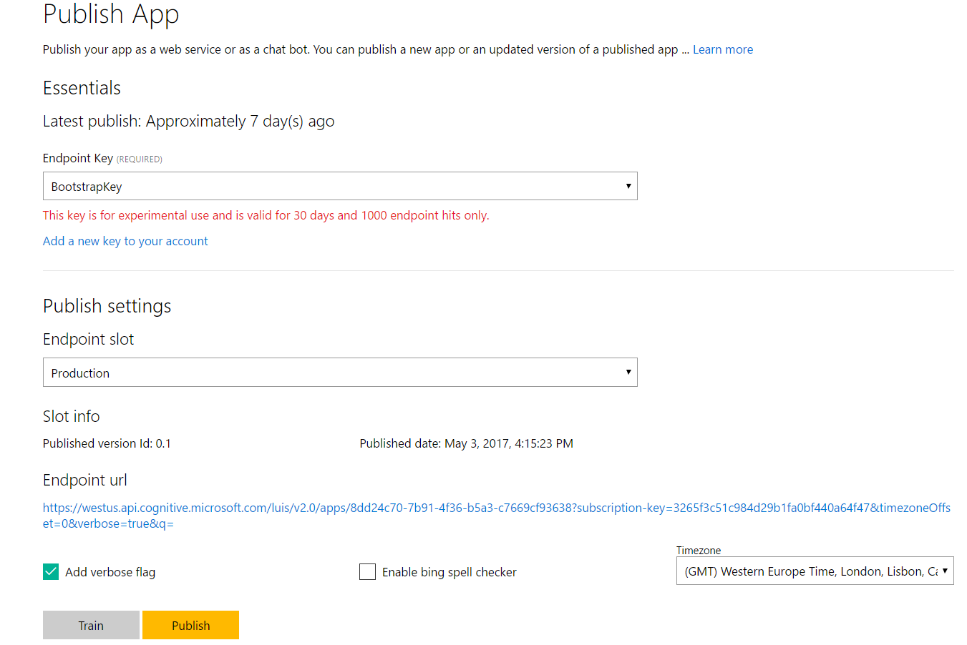

Select an endpoint, click train and then select the publish button to generate the endpoint link.

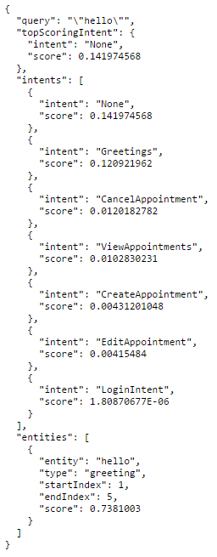

Sample LUIS.ai endpoint prediction result.

**Bot Connector and Service Implementation**

* Register the bot in <https://dev.botframework.com/bots/new> after successful implementation of the bot connector.
* In the Web.config file of Bot service give generated Bot ID, MicrosoftAppId, MicrosoftAppPassword values, if to test locally make App ID, Password values to blank.

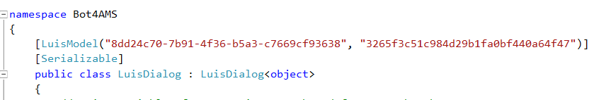

Using the App ID and LUIS Endpoint in Bot project.

* Use the build and publish from visual studio to start the bot service. Use the Bot emulator to start interacting with the Bot service by connecting the below URL.
  + <http://localhost:3979/api/messages> i.e., Port number might be different in each case.

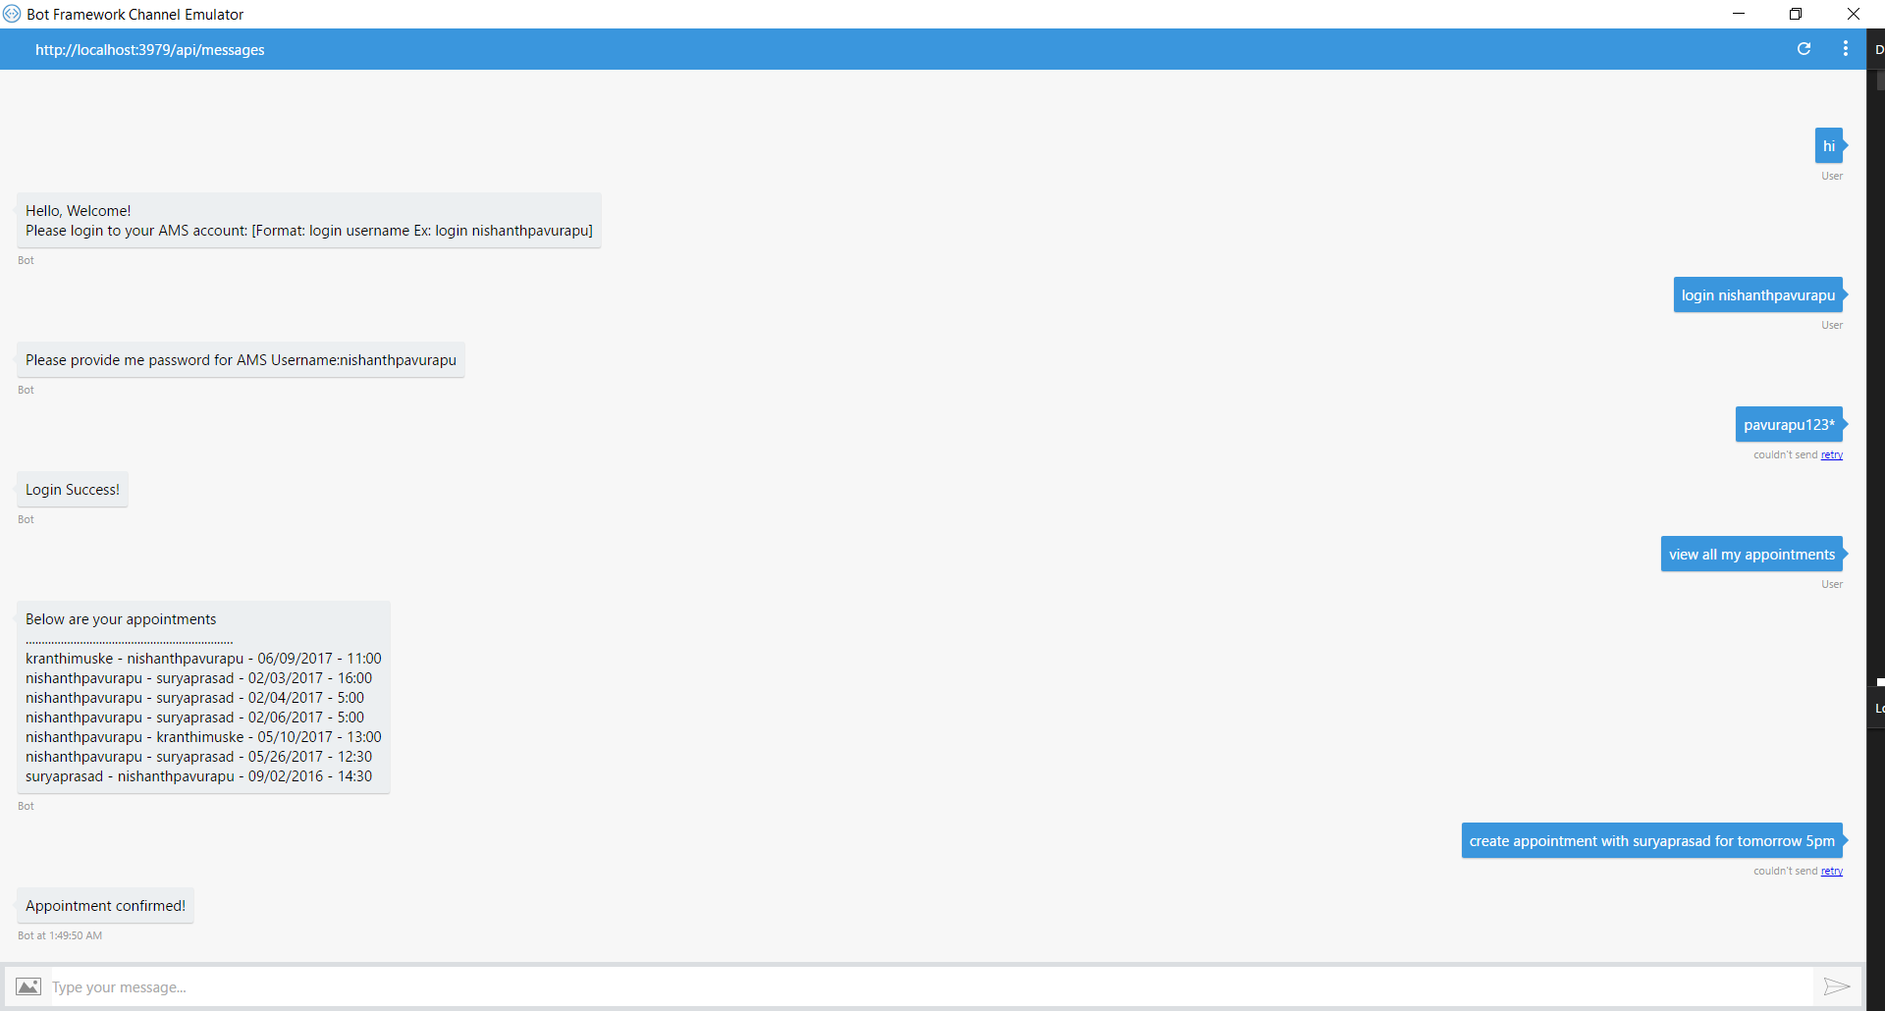

Using the emulator to communicate with bot service.